Day 3:

**Docker Port**

1. Pull nginx image from dockerhub.  
   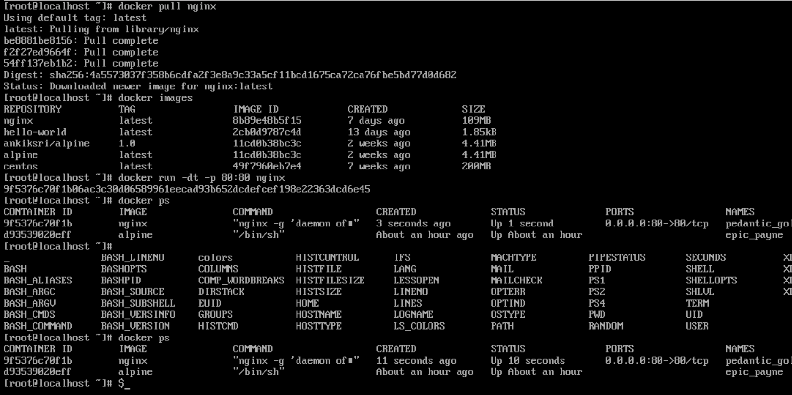
2. Run a container from nginx image and map container port 80 to system port 80.  
   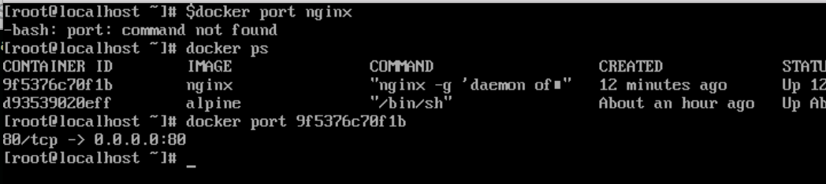
3. Display all mapped ports on nginx image.  
   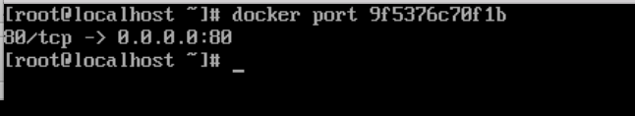  
     
   **Docker Volume**
4. Create docker volume named "dbvol"  
   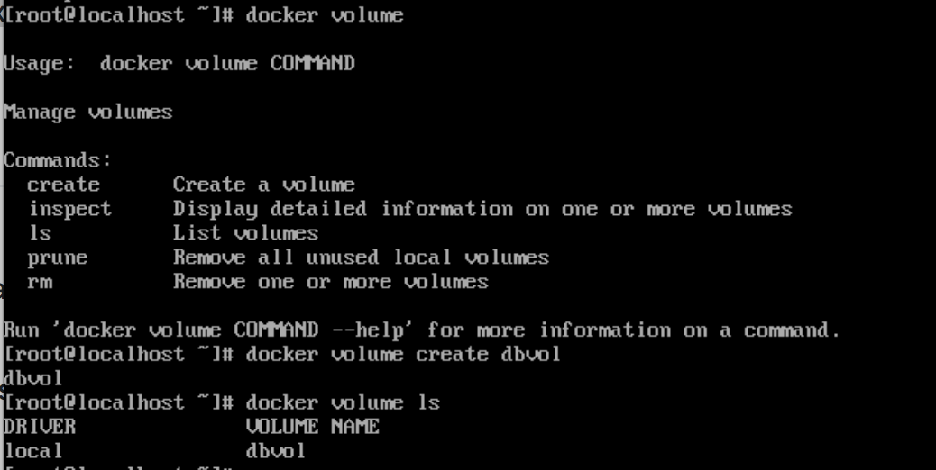
5. Run docker container from wordpress image and mount "dbvol" to /var/lib/mysql  
   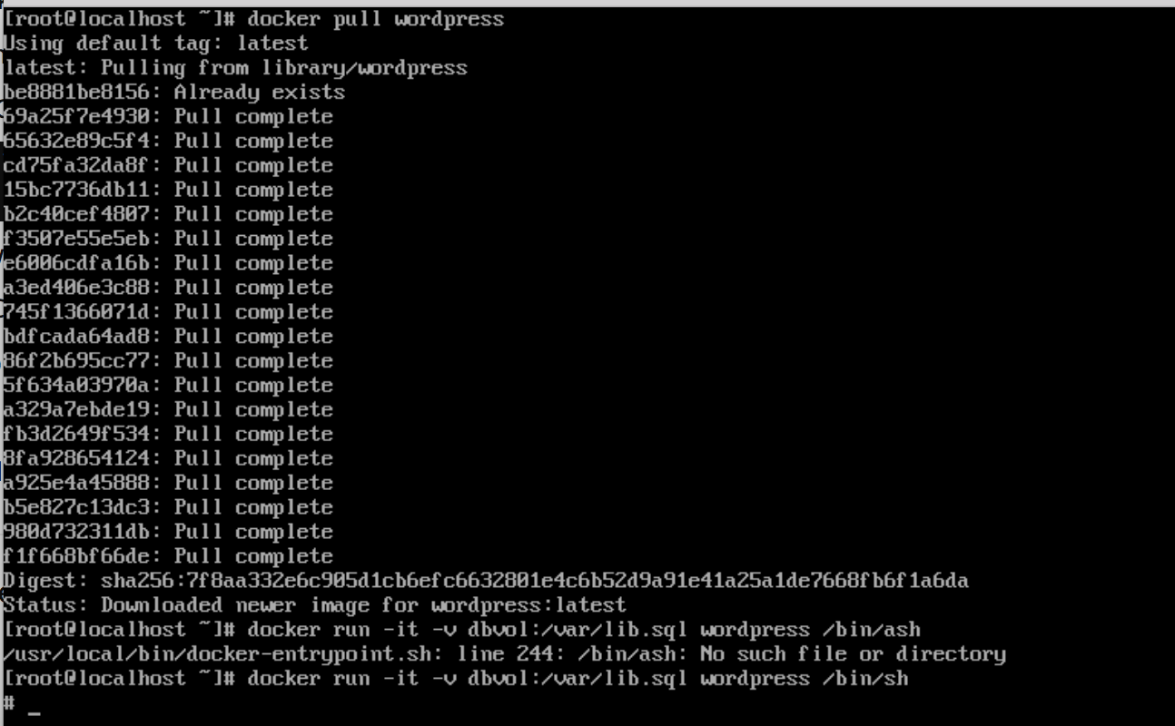
6. Display all docker volumes.  
   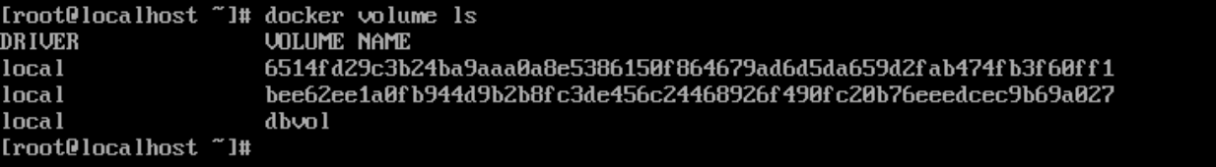
7. Create another docker volume named "testvol"  
   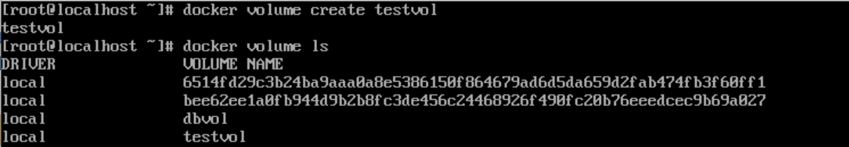
8. Remove docker volume "testvol"  
   